. Create two list and joint those two list

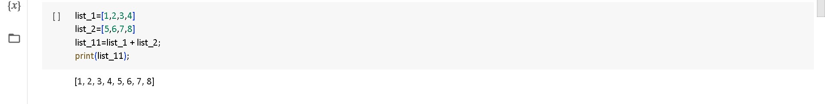

. with if statement find the even number:

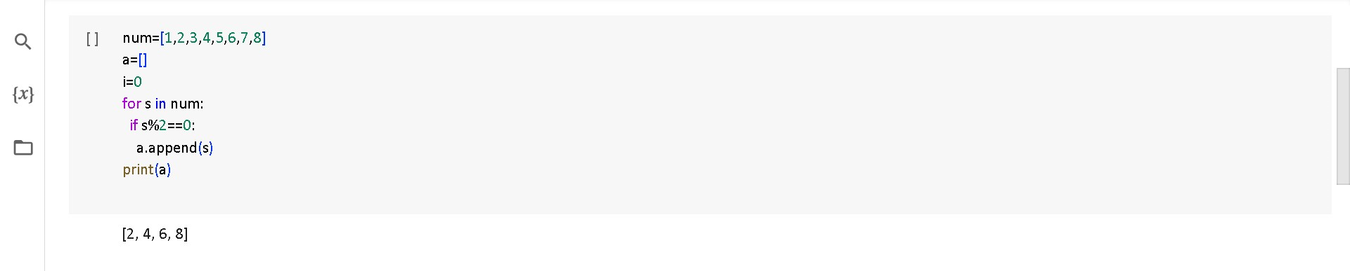

**. Create a dictionary with 3 key and 2 values for each key:**

